INDIAN SCHOOL AL WADI AL KABIR

Class: VII | Department : Computer Science
Holiday Homework | Topic: Advanced Features of Excel 2016 | Year :2025-2026
- Create students records using the form and Sort the data first by Grade (highest to lowest), then by Name (A to Z) within each grade.

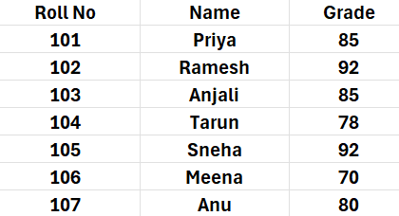
- Calculate total sales for each region using the Subtotal feature in Excel.

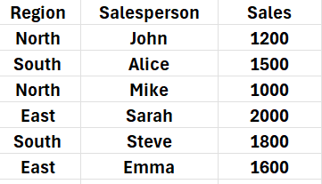
- Create the following records and highlight duplicates in the "Product Name" column using Conditional Formatting.

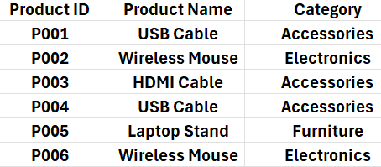

Note: Practice this worksheet , Evaluation will be done after holidays during practical session

1| 26- 0 5 - 2 0 2 5/ P R E P A R E D B Y : SMRUTHY BABY / I C T D e p t .

